**Ex2 Report:**

We got the following accuracy for the 3 models:

1. Standard multi-class perceptron- We received 68.8% accuracy (running the code for 5 epochs, improving it to 70.14% in 10 epochs).
2. Multi-class perceptron as structured perceptron- We received ~68.8% accuracy (running the code for 5 epochs), just like the above.
3. Structured perceptron with bigram features- We received 81.01% accuracy (running 3 epochs).

Comparing the different methods/models, it is obvious that the best results are given when using the structured perceptron with bigram features. In addition to learning just the letters of a word, we learn their bigrams- which give us much better indication to predicting the next letter. The difference between the first and second models are minor, having a standard multi-class perceptron, and an “almost standard” one just with padded input. Their results were identical, with the first one having a slightly shorter runtime.

**Bonus 1:**

**Normalized:**

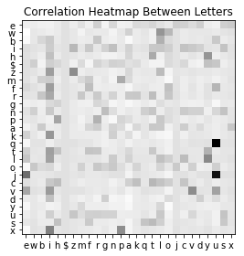

**With no normalization:**

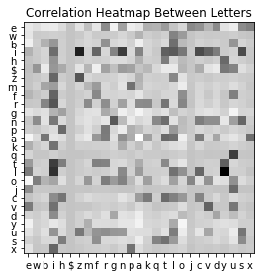

**Bonus 2:**

Changing the structured perceptron to a structured SVM, would result in a better model.